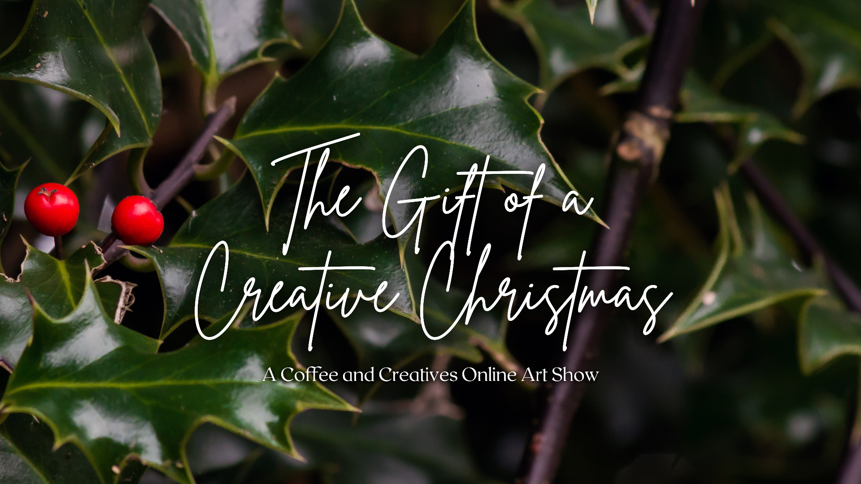

Artist Information
- First Name: _________________________________
- Last Name: _________________________________
- Website and/or Social Media Handle: __________________________________
- Artist Statement (maximum of 250 words):
________________________________________________________________
________________________________________________________________
________________________________________________________________
________________________________________________________________

- Artist Bio (maximum of 250 words):
________________________________________________________________
________________________________________________________________
________________________________________________________________
________________________________________________________________
________________________________________________________________

Artwork Information
*You may submit up to three
Artwork #1
- Title: _________________________________
- Year of completion: _________________________________
- Medium/type of art: _________________________________
Artwork #2
- Title: _________________________________
- Year of completion: _________________________________
- Medium/type of art: _________________________________
Artwork #3
- Title: _________________________________
- Year of completion: _________________________________
- Medium/type of art: _________________________________

Submission Fee Information
*$10 must be sent via PayPal to coffeeandcreativesproject@gmail.com by December 18, 2021.

The email that the submission fee was sent through on PayPal (we will verify payments after December 18, 2021): _________________________________

Submitting to the Contest
- Email this form and your artwork to coffeeandcreativesproject@gmail.com.
- Send $10 to coffeeandcreativesproject@gmail.com through PayPal.

If you have any questions or concerns, feel free to contact us at coffeeandcreativesproject@gmail.com.

Please note that there is a $10 submission fee, which supports Coffee and Creatives as an independent podcast and blog. As such, we truly understand the barrier submission fees can create, while also valuing the time and effort that goes into creative work and all the behind-the scenes administrative work of supporting artists. In order to break down this barrier while also valuing our own time, this is a sliding fee scale opportunity with a suggested fee of $10 to support the work that we do, but with the opportunity to apply for as low as $8 if you are unable to pay the suggested fee.

